SECTION 8

Chapter 1

Ethernet Fundamentals

Opening: Why Ethernet Matters
In the early days of computer networking, there were many different Layer 2 technologies competing for dominance, and there wasn’t much standardization between them. This lack of standardization created real operational problems because networks and devices didn’t always work smoothly together.
The instructor recalls a time when networks commonly used many competing Layer 2 technologies, including: Ethernet, Token Ring, LocalTalk, AppleTalk, NetBIOS, IPX/SPX, Frame Relay, ATM (Asynchronous Transfer Mode), FDDI (Fiber Distributed Data Interface), PPP (Point-to-Point Protocol), HDLC (High-Level Data Link Control), ISDN (Integrated Services Digital Network), and many others.
Out of these “Layer 2 wars,” there was one clear winner: Ethernet. Ethernet became (and still is) the number one protocol used for Layer 2 communications in most modern LANs. The lesson emphasizes that if you don’t understand Ethernet, you don’t fully understand how modern local area networks operate.

Ethernet’s Early History: Coaxial Days
Ethernet has been around for a long time. Originally, Ethernet ran over coaxial cable using BNC connectors and vampire taps. Two major early Ethernet forms were:
- 10Base2 (ThinNet)
- 10Base5 (ThickNet)
They were nicknamed ThinNet and ThickNet because of the relative thickness of the coax cables.
A major advantage of these coax Ethernet networks was distance:
- 10Base2 could reach up to 200 meters
- 10Base5 could reach up to 500 meters
For the Network+ exam today, you do not need to memorize 10Base2 or 10Base5 because they’re very old and unlikely to appear in real-world environments now. They are mentioned mainly to show what Ethernet looked like when it was first introduced in the 1980s.

The Shift to Twisted Pair: 10Base-T
Over time, networking shifted to 10Base-T Ethernet, which supported:
- 10 Mbps data transfer
- Running over twisted-pair cabling
- Specifically Category 3 (Cat 3) cable
These twisted-pair cables could be:
- Unshielded, or
- Shielded
They were cheaper and easier to use compared to the older coax (10Base2/10Base5).
The key disadvantage of 10Base-T compared to coax was distance:
- 10Base-T could only run up to 100 meters
- After 100 meters, the signal would need to be repeated using a hub or a switch
Even though 10 Mbps sounds small today, it was extremely fast back then. The lesson compares it to dial-up modems of that era, which were often lucky to reach 300 bits per second. In that context, 10 Mbps LAN speed felt “lightning fast.”

The Core Problem Ethernet Had to Solve: How Devices Share the Network
As network speeds increased, a major question had to be answered:
How do multiple devices access the same network medium and communicate without chaos?
The lesson presents two possible approaches:

1) Deterministic Access (Orderly and Controlled)
A deterministic network uses an organized system where a device must wait for permission before transmitting. A classic example is Token Ring.
In a Token Ring–style approach, a device can only transmit when it receives an electronic “token” that signals it is that device’s turn.

Classroom analogy (Deterministic)
Imagine a classroom with 20–30 students. If everyone talks at once, nobody can be understood (collisions). Instead, students raise their hands, and the instructor calls on them. That “permission to talk” is like the token. The instructor controls who speaks and for how long.
Benefit of deterministic access:
There are essentially no collisions, because everyone waits their turn.

2) Contention-Based Access (Flexible but Chaotic)
A contention-based network is more natural and flexible but can be chaotic because devices attempt to transmit whenever the medium seems free.

Pub analogy (Contention-based)
Think of a group of friends at a pub on a Friday night. Nobody formally moderates the conversation. People speak when they hear a gap. Sometimes two people speak at the same time—this causes a “collision.” When that happens, one person stops and waits for another gap to try again.
The lesson notes that Ethernet is contention-based.

Why choose contention-based if it can cause collisions?
Because contention-based networks have lower overhead. They don’t require passing a token around, and they can make better use of the network’s bandwidth because anyone can transmit whenever needed.
The lesson explains a key efficiency problem in deterministic systems: even if you divide time fairly among devices (time slots), many devices won’t always have data to send. That means large portions of the network’s capacity can be wasted waiting in silence. The pub analogy shows this clearly: some people might use their full minute, but others might speak for 15 seconds and waste the remaining 45 seconds, leaving everyone waiting.
Ethernet was designed to maximize efficiency by allowing devices to use the bandwidth when they actually need it, rather than reserving fixed turns that may go unused.

How Ethernet Handles Collisions: CSMA/CD
If Ethernet lets anyone transmit at any time, collisions can happen. Ethernet addresses this using:
CSMA/CD — Carrier Sense Multiple Access with Collision Detection
This works similarly to the “pub conversation” behavior: listen first, talk when it’s quiet, and if a collision happens, stop and try again later.

Breaking down CSMA/CD

CS — Carrier Sense
Ethernet devices listen to the network to determine whether a signal is already being transmitted.
The lesson clarifies that a carrier is the signal that carries information over a medium, such as:
- a cable
- fiber
- radio frequency waves

MA — Multiple Access
Many devices share the same network medium, and each device has the ability to:
- listen
- access
- transmit
So multiple devices are “contending” for access.

CD — Collision Detection
If a device detects a collision while transmitting, the devices stop and take steps to retransmit.

Random Backoff Timer (What happens after a collision)
When a collision occurs:
- Both devices stop transmitting immediately
- Each device picks a random number
- Each device waits that many milliseconds
- When its timer expires, it listens again
- If the line is clear, it retransmits
This is called a random backoff timer.

Hallway analogy (Collision + backoff)
Two people walking toward each other in a narrow hallway sometimes do the awkward left-right “dance” where neither passes. The instructor resolves it like Ethernet: stop, count to two or three, let the other person pass, and then proceed. That pause is the “backoff,” and it breaks the collision loop.

Visualized Example: Six Devices on a Shared Segment
The lesson uses a simple example with six devices on a network, drawn as a bus topology to make it easy to picture (even though Ethernet can be used with star, bus, ring, and other topologies).
- If device 4 talks to device 5 while nobody else is transmitting, communication succeeds.
- If device 2 wants to talk to device 1, it carrier-senses the line is clear and transmits successfully.

Collision example
If device 3 and device 5 transmit at the same time:
- Both listen (carrier sense) and think the line is clear
- They transmit simultaneously
- A collision occurs
- Both stop and choose random backoff timers
Example random timers used in the lesson:
- Device 3 waits 30 ms
- Device 5 waits 150 ms
After 30 ms:
- Device 3 checks the carrier, sees it’s clear, transmits.
- Device 5 is still waiting (needs 120 ms more).
After 150 ms:
- Device 5 checks the carrier again.
- If device 3 is still transmitting, device 5 waits for the next open gap (the lesson describes this as occurring after device 3 finishes—about another 180 ms in the example).
- Then device 5 transmits.
If another collision happens during retransmission attempts, the process repeats: stop, random backoff, retry—until everything gets transmitted.

The Big Scaling Problem: Collision Domains
The lesson directly acknowledges that this approach becomes worse as networks get busier:
- More devices on the same segment → more collisions
- More collisions → more retransmissions
- More retransmissions → lower effective bandwidth and slower performance
A collision domain is any portion of the network where devices share the same medium and collisions can occur.
A collision happens when two devices send data at the same time on the same network path, causing the data to crash into each other and fail.
So, a collision domain is the area where those collisions are possible.
In the bus example:
- All six devices share one cable
- That entire cable segment is one collision domain
The lesson states that with Ethernet:
- Devices on the same cable segment share a collision domain
- Devices connected to a hub share a collision domain

Duplex Mode: Half Duplex vs Full Duplex
Because devices share the same medium in a collision domain, they must operate in half duplex:
- They can listen or talk, but not both at the same time
If a device tried to listen and talk simultaneously on a shared segment, it would essentially hear itself and interpret that as someone else transmitting, which disrupts communication. So on hubs/shared segments, full duplex isn’t practical because collisions would be too frequent.

Why Hubs Don’t Scale and Switches Do
The lesson explains that you must keep collision domains small.
- A small hub with four devices might be manageable.
- A 24- or 48-port hub creates a huge collision domain, causing collisions to explode and performance to collapse (“bring your network to a screeching halt”).
The pub analogy returns:
- 4 people at a table can manage a conversation.
- 20–25 people at one table causes too many collisions.
- The solution is to split into multiple tables (smaller groups).

Network equivalent: switches and bridges
To break up collision domains, networks use Ethernet switches or bridges.
The key scaling advantage:
- Every switch port is its own collision domain.
So instead of all devices sharing one collision domain (like with a hub), each device has a dedicated collision domain to the switch port it’s connected to.

The Performance Boost: Full Duplex with Switches
When a device is connected to a switch port:
- Only that device and the switch exist on that small segment
- There’s no competition from other devices on that segment
- Therefore, collisions are essentially eliminated on that link
Because collisions aren’t a concern on a dedicated switch port link:
- The link can operate in full duplex
- The device doesn’t have to “listen before talking” in the same way as a shared segment
- This increases effective throughput and allows faster data transfer
The instructor uses a simple analogy:
- If you’re alone in a room, you can talk freely without collisions.
- A switch port connection is like that dedicated private space.

Final Takeaways (What the Lesson Wants You to Remember)
Ethernet is the preferred Layer 2 protocol used in modern networks for most use cases. Ethernet is contention-based and historically relied on CSMA/CD concepts to handle collisions in shared segments.
For modern networks, you should use switches instead of hubs because:
- A hub creates one large collision domain → many collisions → half duplex
- A switch creates many small collision domains (one per port) → minimal collisions → full duplex
- Smaller collision domains improve scalability and real network performance
That’s why switches are foundational to how modern Ethernet LANs operate today.

Chapter 2

Network Infrastructure Devices

1. What You Must Know for the Network+ Exam
For the Network+ exam, you must be able to identify network infrastructure devices. That means:
- Recognizing their icons
- Knowing what they do
- Knowing what collision domains they break up (or don’t)
- Knowing what broadcast domains they break up (or don’t)
The lesson focuses on the primary devices used in networks today—routers and switches—and explains how these evolved from older devices like hubs and bridges. The lesson starts with hubs and builds toward modern devices.

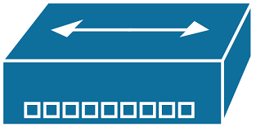
2. Hubs (Layer 1)

What a Hub Is
A hub is a Layer 1 (physical layer) device. It connects multiple devices/workstations together and simply repeats signals.
- Icon identification: a square icon with an arrow pointing in both directions
- Another name: multi-port repeater
- Behavior: whatever comes into one port is repeated out the other ports

Types of Hubs
There are three types:

A) Passive Hub
- Repeats the signal
- No amplification
- Works like a splitter
- Example: On an 8-port passive hub, traffic entering port 1 is repeated out ports 2–8

B) Active Hub
- Repeats the signal and amplifies/boosts it
- The purpose of boosting is to help overcome the 100-meter twisted-pair limitation
- Important concept: an active hub “restarts” the 100-meter count
Why passive hubs fail for distance
If you have:
- a 100-meter cable → passive hub → 50-meter cable
the network behaves like a single 150-meter run, which causes problems.
Why active hubs help
An active hub has power and boosts the signal so you can chain segments and still respect the 100-meter rule per segment.
Example from the lesson (300-meter building)
- Building length: 300 meters
- Cat5 max segment: 100 meters
- Strategy: run 60–70 meters, place an active hub, then repeat.
Why only 60–70 meters instead of 100 meters?
- Best practice: use only about 60–70% of max length
- Helps avoid mistakes in measurement and prevents accidentally exceeding 100 meters
The instructor explains the difference in counting:
- Passive hub chaining adds distance together (bad)
- Active hub chaining treats them as separate segments (good)

C) Smart Hub
- A smart hub is an active hub with management features
- Includes capabilities like SNMP (Simple Network Management Protocol)
- Allows remote monitoring/control/configuration
- Adds “intelligence” compared to a dumb hub

Modern Reality
In modern networks, you typically won’t see hubs. Switches are used almost exclusively (and the lesson explains why).

3. Collision Domains (Why Hubs Cause Problems)
A hub is a Layer 1 “dumb” device. Because it repeats everything, when you use hubs to connect multiple segments together, you actually create a larger collision domain.
Key point:
- Hubs do NOT break up collision domains
- Hubs connect collision domains into one bigger one

Hub Example from the lesson
- Two 4-port hubs connected together
- Three PCs on the left hub, two PCs on the right hub
- The hubs communicate with each other
Result:
- This behaves as if all devices are on one long bus cable
- All devices are in one large collision domain
Why this matters:
- Bigger networks + hubs (24-port, 48-port hubs) → many devices talk → lots of collisions → performance collapses
This problem introduces the next device: the bridge.

4. Bridges (Layer 2)
A bridge is a Layer 2 device. It improves efficiency by making forwarding decisions based on MAC addresses.

What a Bridge Does
- Reads the source MAC address in frames
- Builds an internal MAC address table
- Uses the destination MAC address to decide whether to forward the frame across the bridge

How Bridges Help
In the earlier hub example with two groups of PCs, placing a bridge between them:
- Splits the big collision domain into two parts
- Keeps local traffic local
- Only forwards traffic between segments when needed (based on MAC address table)
- Improves:
  - Efficiency
  - Security (because unnecessary devices don’t hear traffic)
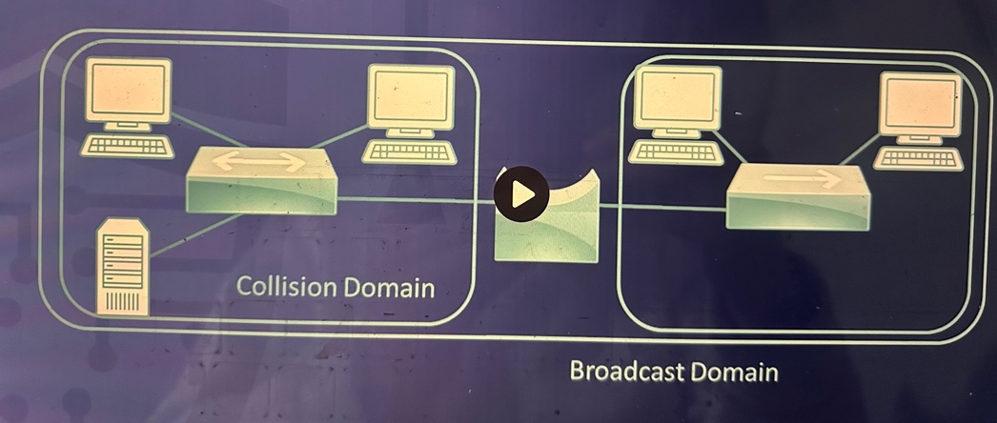

5. Switches (Layer 2)
A switch is essentially what you get when you “marry” a hub and a bridge together.

What a Switch Is
- A switch is a Layer 2 device, like a bridge
- It connects multiple network segments, like a hub
- Best mental model from the lesson: a switch is a multi-port bridge

What the Switch Does Internally
- Learns MAC addresses by reading the source MAC
- Stores those MACs in its internal MAC address table
- Forwards frames based on the destination MAC
- Each port behaves like it has its own “bridge logic”

Collision Domains vs Broadcast Domain (Key Exam Point)
With a standard Layer 2 switch:
- Each switch port is its own collision domain
- Everything on the switch is in the same broadcast domain

6. Switch Operation Example: ARP + MAC Learning (Detailed Walkthrough)
The lesson uses a real-world example to show why switches are efficient.

Scenario
- PC1 wants to SSH into a server
- PC1 MAC = BB (simplified)
- Server MAC = CC (simplified)
- Two switches are involved (Switch 1 and Switch 2)
- Initially, switch MAC tables are empty

Step 1: PC1 needs to find CC (ARP begins)
PC1 sends an ARP packet asking: “Who has CC?”
- Switch 1 receives the ARP
- Switch 1 checks its table: CC is unknown
- But Switch 1 learns something immediately:
  - It learns BB is on port 0/1
  - So it adds BB → port 0/1 to its MAC table
- Since CC is unknown, Switch 1 floods the ARP out all other ports
Other devices respond:
- PC2: “Not CC” (ignores)
- PC5: “Not CC” (ignores)
Switch 2 receives the ARP flood:
- Switch 2 doesn’t know CC either
- Switch 2 floods it out all ports in its broadcast domain (to PC3, PC4, and the server)
- Switch 2 also learns that BB is reachable via the link back toward Switch 1, so it records where BB is in its table

Step 2: The server responds
The server recognizes itself as CC, and replies with an ARP response.
- Switch 2 receives server’s reply
- Switch 2 learns CC is on port 0/2 and updates its table
- Switch 2 forwards the reply back toward Switch 1
- Switch 1 receives the reply
- Switch 1 learns CC is reachable via port 0/2
- Switch 1 forwards the reply to PC1
At this moment:
- The whole network was “bothered” once to discover CC
- But now the switches know where BB and CC are

Step 3: Now the real traffic is efficient (SSH)
When PC1 sends SSH traffic to CC:
- Switch 1 does not flood
- Switch 1 forwards only out port 0/2 (where CC is known to be)
- Switch 2 forwards only out its port 0/2 (directly to the server)
Result:
- PCs (PC2, PC3, PC4, PC5) do not hear this traffic
- Bandwidth waste is minimized
- Security improves because unnecessary devices don’t see the traffic

Full Duplex Efficiency
The lesson adds that switches support full duplex, which allows multiple conversations at the same time without collisions:
- Server ↔ PC1 can communicate
- PC2 ↔ PC3 can communicate simultaneously
- They do not interfere with each other
This is a major source of efficiency in switched networks.

🔹 How a switch normally works (UNICAST)
For normal traffic:
- Frame has a destination MAC
- Switch checks its MAC address table
- Sends the frame only to the correct port
👉 This is unicast forwarding

🔹 What is DIFFERENT about a BROADCAST
A broadcast frame has this destination MAC:
FF:FF:FF:FF:FF:FF
This MAC address means:
“Send to everyone on the local network.”
So when the switch sees this MAC:
- It does NOT look for a specific port
- It intentionally floods the frame

🔹 Why the switch floods broadcasts
Because:
- Broadcasts are required for basic networking
- Example: ARP
“Who has IP 192.168.1.1? Tell me your MAC.”
If the switch didn’t flood:
- Devices couldn’t discover each other
- Networking would break

🔹 What the switch actually does (step-by-step)
- PC sends frame with destination MAC = FF:FF:FF:FF:FF:FF
- Switch reads the frame header
- Switch recognizes it as a broadcast
- Switch forwards the frame to:
  - All ports
  - Except the one it came in on
📌 This is called broadcast flooding

🔹 Across multiple switches
If switches are connected together:
- Each switch repeats the same behavior
- Broadcast spreads across the entire Layer 2 network
Until it hits:
- ❌ A router
- ❌ A VLAN boundary

🔹 Key exam distinction (VERY IMPORTANT)
Traffic Type | How switch handles it
Unicast | Sends to one port
Broadcast | Sends to all ports
Unknown unicast | Floods to all ports

- Routers (Layer 3)

🔹 What problem exists BEFORE the router
With only switches:
- Broadcasts are flooded to all ports
- They spread across all connected switches
- Network = one big broadcast domain
- Result: ❌ noise, ❌ wasted bandwidth, ❌ poor scalability
Switches must forward broadcasts — they cannot stop them.

A router operates at Layer 3 (IP) and does NOT forward Layer-2 broadcasts.
👉 This is the BIG rule:
Routers stop broadcasts by default
Switches are Layer 2 and use MAC addresses. That works inside a LAN, but it doesn’t solve the problem of connecting to dissimilar networks, like:
- Internal network (LAN)
- External network (Internet)
To connect different networks, you need routing decisions based on Layer 3 logical addressing:
- IPv4
- IPv6

Key Router Concepts
- Routers make routing/forwarding decisions based on IP addressing
- Routers are Layer 3 devices
- Routers are more feature-rich and support many interface types
Examples of router interfaces mentioned:
- Serial ports
- Copper RJ45
- ST fiber connectors
- GBIC
- SFP
- QSFP
The lesson contrasts this with switches:
- Switches tend to be mostly one type (all copper or all fiber), depending on the model

Broadcast Domain Separation (Major Router Advantage)
Routers can separate broadcast domains.
Example from the lesson:
- Without a router, multiple switch-connected PCs could still be part of one large broadcast domain (even though collision domains are separated by switch ports)
- With a router in place, you now have two separate broadcast domains
- This reduces traffic/noise and improves efficiency
The lesson notes that detailed routing operation will be covered later because routers have a lot to them.

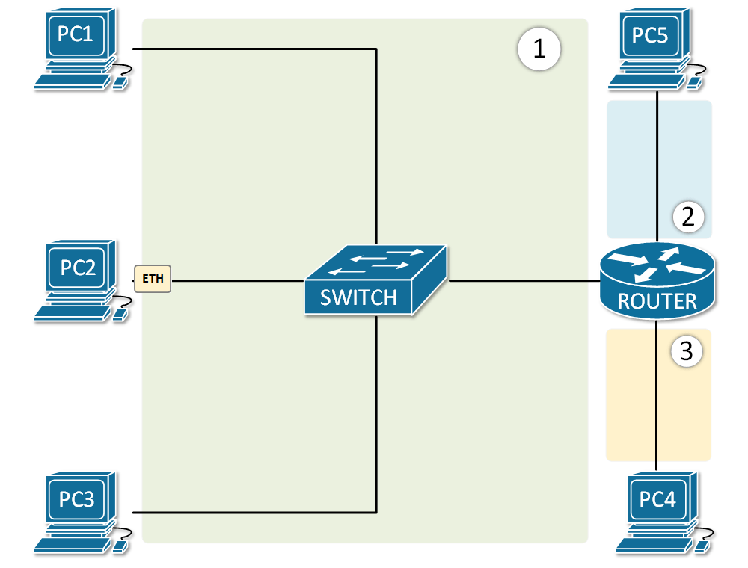

✅ Case 1: PC sends a BROADCAST (ARP example)

Scenario
- PC-A wants to talk to its default gateway (router)
- PC-A does not know the router’s MAC address

🧭 Step-by-step flow (BROADCAST)

1️⃣ PC creates a broadcast message
PC-A sends an ARP Request:
“Who has IP 192.168.1.1? Tell me your MAC.”
Frame details:
- Destination MAC: FF:FF:FF:FF:FF:FF (broadcast)
- Source MAC: PC-A
- Destination IP: 192.168.1.1 (router)
- Source IP: PC-A

2️⃣ Switch receives the frame
- Switch sees destination MAC = broadcast
- Switch does NOT check MAC table
- Switch floods the frame to:
  - All ports
  - Except the incoming port
📌 All PCs and the router interface receive it

3️⃣ Router receives the broadcast
- Router sees:
  - Destination MAC = broadcast
  - ARP request asking for its own IP
✔ Router processes it
❌ Router does NOT forward it

4️⃣ Router replies (UNICAST)
Router sends an ARP Reply:
“192.168.1.1 is at AA:BB:CC:DD:EE:FF”
Frame details:
- Destination MAC: PC-A
- Source MAC: Router
- UNICAST

5️⃣ Switch forwards reply
- Switch learns router MAC
- Sends reply only to PC-A
✅ Communication established
🚫 Broadcast stopped at router

❌ Case 2: PC sends a broadcast meant for “everyone”
Example: a random Layer-2 broadcast

1️⃣ PC sends broadcast
- Destination MAC = FF:FF:FF:FF:FF:FF

2️⃣ Switch floods it
- All ports receive it
- Router interface receives it too

3️⃣ Router behavior (IMPORTANT)
- Router sees broadcast
- Drops it
- Does NOT forward to other networks
📌 Broadcast dies here

✅ Case 3: PC sends data to a device on another network (UNICAST)
This shows why routers are used.

1️⃣ PC sends packet to external IP (e.g. 8.8.8.8)
PC knows:
- Destination is not local
- Must send to default gateway
Frame:
- Destination MAC: Router MAC
- Destination IP: 8.8.8.8
- UNICAST

2️⃣ Switch forwards it
- Switch looks up router MAC
- Sends frame to router port only

3️⃣ Router processes packet
- Router strips Layer-2 header
- Reads destination IP
- Checks routing table
- Chooses next hop
- Creates new frame
- Forwards packet onward
🚀 Packet routed successfully

🧠 Key takeaway (this is the heart of it)
- Switch: forwards based on MAC (broadcasts flooded)
- Router: routes based on IP (broadcasts blocked)

🔑 One-line exam version
A switch floods broadcast frames, but a router processes only relevant broadcasts and never forwards them, routing only unicast IP traffic.

- Layer 3 Switches (Multi-layer Switches)

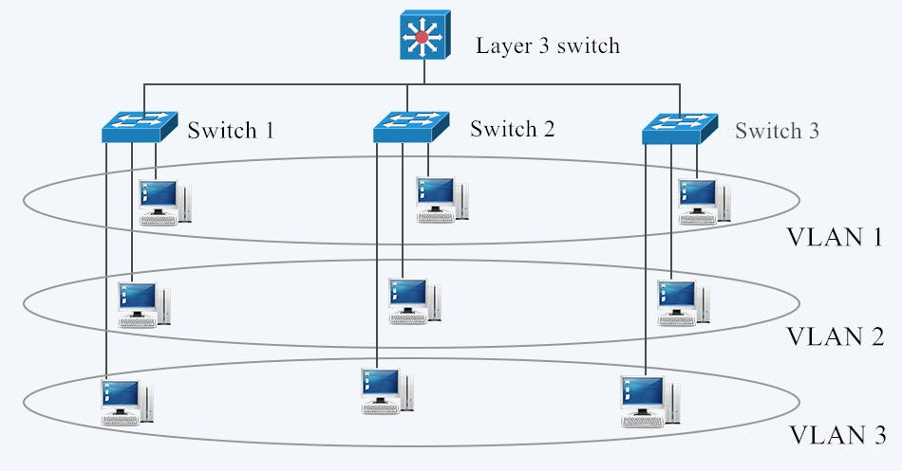
This is a concept that confuses many students.
Historically:
- Hub + Bridge → Switch (Layer 2)
Similarly:
- Switch + Router → Layer 3 switch (Multi-layer switch)

What a Layer 3 Switch Is
- A Layer 3 device
- Used to connect multiple networks
- Can perform routing functions like a router
- Can connect segments like a switch

Domains on a Layer 3 Switch
Because it behaves like a router:
- Each port acts as its own broadcast domain
- Each port acts as its own collision domain
This can be very efficient inside an internal network.

When to Use / Not Use (as stated in lesson)
- Small office/home office (20–30 machines):
  - You can replace a router + switch with one Layer 3 switch
  - Saves money and works well
- Very large networks:
  - The instructor prefers a dedicated router
  - Reason: dedicated routers are better/faster for large-scale routing operations

🧠 What this diagram represents (big picture)
- Top device = Layer 3 switch
- Bottom devices = Layer 2 access switches (Switch 1, 2, 3)
- Horizontal ovals = VLANs
  - VLAN 1
  - VLAN 2
  - VLAN 3
👉 Each VLAN is a separate broadcast domain

🔹 Step 1: VLANs span multiple switches
Look carefully:
- VLAN 1 exists on:
  - Switch 1
  - Switch 2
  - Switch 3
Same for VLAN 2 and VLAN 3.
📌 Important point
Even though PCs are on different physical switches, if they are in the same VLAN, they are:
- In the same broadcast domain
- Can communicate at Layer 2
Example:
- PC in VLAN 1 on Switch 1
- PC in VLAN 1 on Switch 3
➡️ They can talk without a router

🔹 Step 2: Trunk links between switches
The links between:
- Switch 1 ↔ Layer 3 switch
- Switch 2 ↔ Layer 3 switch
- Switch 3 ↔ Layer 3 switch
are trunk links.
What trunking does:
- Carries multiple VLANs over one cable
- Uses VLAN tags (802.1Q)
This is why VLAN 1, 2, and 3 can exist on all switches.

🔹 Step 3: Broadcast behavior (VERY important)

Inside a VLAN
- Broadcasts stay inside the same VLAN
- VLAN 1 broadcasts go only to VLAN 1
- VLAN 2 broadcasts go only to VLAN 2
🚫 Broadcasts do NOT cross VLANs

🔹 Step 4: Role of the Layer 3 switch (key part)
The Layer 3 switch:
- Has an SVI (virtual interface) for each VLAN
  - VLAN 1 → IP gateway
  - VLAN 2 → IP gateway
  - VLAN 3 → IP gateway
These SVIs act like router interfaces.
📌 This allows inter-VLAN routing.

🔹 Step 5: Example traffic flow (this is the “aha” moment)

Example: PC in VLAN 1 → PC in VLAN 2
1️⃣ PC in VLAN 1 sees destination is not in its subnet
2️⃣ PC sends traffic to its default gateway (SVI on Layer 3 switch)
3️⃣ Layer 3 switch:
- Reads destination IP
- Routes traffic to VLAN 2
- Rewrites Layer-2 frame
4️⃣ PC in VLAN 2 receives traffic
✅ Unicast traffic routed
🚫 Broadcasts blocked

9. Summary Chart (Devices, Domains, and OSI Layers)
The lesson ends with a summary of five device types:
- Hubs
- Bridges
- Switches
- Multi-layer (Layer 3) switches
- Routers

Collision and Broadcast Domains Summary
Device | OSI Layer | Collision Domains | Broadcast Domains
Hub | Layer 1 | 1 total (shared) | 1 total
Bridge | Layer 2 | One per port | 1 total
Switch (Layer 2) | Layer 2 | One per port | 1 total
Router | Layer 3 | One per port/interface | One per port/interface
Multi-layer / Layer 3 Switch | Layer 3 | One per port | One per port
The lesson also reinforces OSI layers:
- Hubs → Layer 1
- Bridges and switches → Layer 2
- Routers and Layer 3 switches → Layer 3

10. Exam Rule: What “Switch” Usually Means
This is an explicit exam warning.
For the exam:
- If the question says “switch”, assume it means a Layer 2 switch
  - Focused on MAC addresses
- If it says “router”, assume Layer 3
  - Focused on IP addresses
- The only exception:
  - If the question specifically says “multi-layer switch” or “layer 3 switch”
  - Then you treat it like a router (Layer 3 behavior)
The instructor points out why this confuses students:
- In real life, many small office/home office switches you buy today are Layer 3 / multi-layer
- But on the exam, “switch” by default = Layer 2 unless explicitly stated otherwise

